
______________________________________________________________________________________

QualiWare Lifecycle Manager

Product Overview

QualiWare Lifecycle Manager provides a set of business modeling capabilities that are extendable to support any type of business modeling a business desires to do. The QualiWare product suite permits the development and management of business and IT architectures, business processes and the management of them, enterprise architecture management, quality management program support, and IT solution development and implementation management. The QualiWare modeling solution provides not only the business model definition and build environment, but also provides for ongoing management and continual improvement of the business models. QualiWare modeling solutions permit alignment across all the business models resident in the repository, whether a business is modeling for the purposes of business process management, quality management programs such as ISO, Six Sigma, Lean Manufacturing, enterprise architecture for business and IT, or for IT solution business.

QualiWare solutions provide an environment for defining, building, managing change to the models, and providing an environment that facilitates quick and efficient response to business change. QualiWare solutions also permit automatic publishing of content from the repository to the web, as well as providing output from the repository in many other output types.

QualiWare Lifecycle Manager operates in a Windows operating system environment. The modeling system can be utilized in a client and/or client-server environment, and the repository can be centrally controlled. QualiWare users can work individually or in a shared repository environment, so that content is integrated and aligned to represent total business scopes and views. The QualiWare user can develop models in an isolated (i.e., sandbox) environment until such time as the work is ready for sharing with other users. Individual and/or group access rights to a specific repository and its content ensure control over content in that repository, but still permit team or group interactions in the development of the business models. The typical library management functions are supported; i.e., revision control, configuration management, check-in, check-out, and release management of final business models.

The following diagram depicts the overall QualiWare Product Architecture. The sections following the diagram provide a functional overview of the capabilities of each of the components.

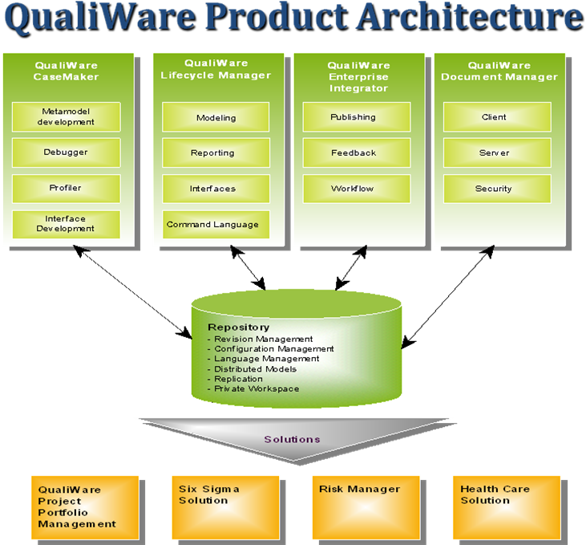

Lifecycle Manager (Kernel)
The kernel of the QualiWare Lifecycle Manager (QLM) provides the repository where business models are stored, basic repository management functions, provides the QualiWare Command Language (QCL) and capabilities associated with the QCL, QLM menus and editors, and document structures and the capability to build and manage them. The kernel is delivered with any one or more of the QLM MetaModels and is a core function that is available for use in conjunction with the MetaModels.

QualiWare Repository
The QualiWare repository is relationally and openly architected and designed so that it is easily extended. The business models can be tailored to the specific needs of the customer, and this open architecture also permits linkage to and storage of existing business documentation.

The QualiWare repository is openly architected and designed to support storage of any template/object that is supported by the QualiWare Lifecycle Manager (QLM) modeling solution. The repository supports a full any-to-any object relationship; i.e., any object in the repository can be linked/related to one or many other objects. The rationale for such a model is based on the need for representing many business relationships so that change management and the impact analyses that support change management can occur. In addition to those objects that are directly supported by QLM, business users of the repository and QLM can also store and link/reference existing intellectual capital (e.g., graphical presentations, models from other tools, spreadsheets, etc.) in the interest of preserving that information but also linking it to the new business models/roadmaps that they are building.

BPD - Business Process Development
The business process development functions permit businesses to design their business processes in a graphical fashion. The graphical representation of the way the business operates permits easy identification of processes and/or activities within processes that are not value adding. The modeling system permits redesign of the processes to eliminate these wasted activities in the business, thus cutting costs from the process and operations of the business. The relational nature of the modeling system permits a business to link the IT systems, organization information, policies, strategies, goals, etc. to the business processes and through these relationships, the system also provides the ability to address future business priorities and requirements as well as how changes will affect the overall business model and environment.

QualiWare BPD is a complete Business Modeling tool intended for systematic development of the business processes. QualiWare BPD covers all steps from the strategic level to the most detailed description of a work process. All models supported in this module and all other modules are fully integrated and make it possible to perform analyses on the business processes to discover points of improvement. QualiWare BPD contributes to a common understanding of the business across and number of business functions.

EAM - Enterprise Architecture Model
QualiWare believes the EA framework should be flexible enough to let a business define one or a few dimensions at a time, versus setting off on a course to build each and every dimension concurrently, each with explicit layers of definition; for this comprehensive path can prove to be a long process for a business and one that is often viewed as unaffordable.

The QualiWare solution set enables flexibility such that a business can build its Enterprise Architecture incrementally. QualiWare believes that the framework of an EA must be flexible enough to allow the definition of architecture dimensions over time, as a business grows and market conditions change.

The QualiWare Lifecycle Manager modeling system provides the functionality to explicitly, graphically depict EA dimensions with innumerable layers of detail. Object-oriented structuring of the system supports any-to-any object relationships such that the EA dimensions can be linked/related multi-dimensionally.

ISD - Information Systems Development
The information systems development functions provide the capability to define high level to low level data and information models and architectures. In addition, graphics user interface design for IT system solutions is available through the ISD capabilities. The ISD capabilities provide high quality designs for the IT systems that are related with the business process designs, thus delivering high quality requirements definitions and functional specifications for IT teams within the business. In conjunction with ISD, the QualiWare modeling system provides the capability of forward and reverse engineering of databases, permitting fast and high quality redesign of data structures.

The ISD MetaModel provides the capability for an Information Systems team to perform structured analysis and design. Systems modeling capabilities are provided via a series of diagramming or modeling: Data Flow and Data Model diagrams, Structure charts, State Event diagrams, Decomposition diagrams and Dialog modeling and layout. There is model validation function built into ISD so that an IS team can validate data models from a data entity relationship, normalization or key perspective. User definable rules can also be added to this validation capability. There is automated documentation creation capability where a pre-viewer permits the user to look at and layout reports prior to printing the reports. Through the use of hyperlinks a user can create and maintain references from descriptive text to graphical design objects. These hyper-links provide consistency and traceability throughout the entire process from requirements specification to implementation. The data modeling support includes the ultimate conversion of the model to DDL (Data Definition Language) for either DB/2 or Oracle. Finally, ISD works with a set of interfaces (DB/2 and Oracle I/Fs are independent QualiWare modules) so that data bases in these DBMS can be reverse engineered and the data models at a physical level are automatically generated.

Project Planning and Estimating
The project planning and estimating functions provide the capability to define high quality and repeatable project methodologies for internal and external project related activities. Project activity level definitions, details regarding expected results, and quality/acceptance criteria within this area of functionality provide businesses with the ability to not only describe and manage project related activities, but also manage the results and the quality of those results. The project related models can be tailored so that unique or specific project approaches for clients and projects can be managed. An interface with Microsoft Project permits the automated generation of a project plan from within the QualiWare modeling system.

QualiWare PPE is for project managers and is focusing on getting a high quality in carrying out project activities in medium and large scale projects. The graphical project models visualize project activities, project deliverables and different kinds of quality assuring activities. QualiWare PPE handles multi level project models allowing detailed description on all levels. The project models are therefore a natural basis for the project participant's when discussing who-is-doing-what-and-when. The project deliverables are connected to the relevant project activities and stored together with information on project progress, time spent by the project participants etc. The Project Planning and Estimating module links project goals and plans, methods and techniques used in the project, planned and actual deliverables, resources spent in the project, and minutes, reports, etc.

QEM - Quality & Environmental Management
The quality and environmental management functions permit businesses to not only develop, but to also manage their overall quality and environmental management systems. Regulatory requirements are factored into the overall management system and business design. This permits a business to assess the overall implications of regulation or standard changes and to extend their business design and management system to address these changes. Whether a business is focused on ISO certification, six sigma, or lean manufacturing, the QualiWare modeling system provides the framework for effective and efficient business process design as part of the overall quality system. Templates and document structures within the modeling system support the ongoing management of the quality or environmental management systems, and the continual improvement cycles of the business designs.

QualiWare QEM is an advanced software tool for building, deploying and administrating Quality Management Systems, Business Excellence Systems and Environmental Management Systems in small, medium and large organizations. Using a combination of diagrams, text, matrices and forms you will quickly build a lean consistent system that is easily understood by the employees. The system is stored in a central database - called a repository - that will manage security, access rights and different versions of the system, as it changes over time. QualiWare QEM combines a set of graphical models to give a holistic view of the company.

QualiWare QEM supports audit planning and in combination with QualiWare Enterprise Integrator you can distribute the quality system over the web and allow users to report Non-Conformances, Preventive Actions and Change Requests directly from the web browser.

QTM - QualiWare Technology Model
The Technology MetaModel is used to describe the computer infrastructure and networks that are in place to run a business.

This set of functions is well suited to documenting and providing an overview of the hardware and software installations, including the use of software licenses and the costs of all parts of the infrastructure.

UML (Unified Modeling Language)
The unified modeling language functions provide the capability to model all aspects of object oriented systems. These functions provide an integrated business design for the IT development teams. In conjunction with UML, the QualiWare modeling system provides the capability of forward and reverse engineering of Java code.

QualiWare UML is a visual modeling tool that supports the Unified Modeling Language for specifying object-oriented systems. It offers all UML diagram types and offers a consistent, easy-to-use modeling environment.

A unique linking capability allows you to specify hyperlinks between any business model component enhancing specification consistency and ensuring traceability from all design components back to the original requirements. QualiWare UML stores all data in multi-user repositories that offer internal revision - and configuration management. This highly scalable solution handles single-user projects as well as multi-user, high volume projects. QualiWare UML can be used with other QualiWare products to include Business Process Modeling, Project Process Support, HTML generation and Roundtrip Engineering.

HTML Converter
The HTML conversion function provides businesses with the ability to take all or any part of their business models, automatically create HTML from those models and supporting detail documentation, and to publish it to any web based facility. This eliminates the need for paper based documents; e.g., quality manuals, business process documentation, operational procedures. Thus, critical business information is quickly and easily shared with all company employees.

QualiWare HTML Converter is an add-on module to the other QualiWare products. QualiWare HTML Converter allows you to distribute all or selected parts of the QualiWare repository content. The HTML pages created by the QualiWare HTML Converter are easily integrated with an intranet. QualiWare HTML Converter allows different HTML profiles for different purposes and lets you specify how data is presented on the web.

Enterprise Integrator
QualiWare Enterprise Integrator provides web based communication with the QualiWare repository directly from the web/internet browser.

QualiWare Enterprise Integrator is installed on a web server with direct access to the QualiWare repository. The installation allows the users to add comments, non-conformances, change requests etc. using the browser. QualiWare Enterprise Integrator automatically updates web pages affected by the changes made to the QualiWare database/repository, making sure that the information presented on the intranet is synchronized with the database.

QualiWare Document Manager
The QualiWare Document Management solution provides basic document management capabilities, but also provides an interface between QualiWare Lifecycle Manager and other industry standard document management solutions so that currently installed and utilized document management solutions and the documents within them can be linked to the enterprise architecture and supporting business models.

CaseMaker
The CaseMaker module provides businesses with the ability to develop their own unique business modeling capabilities, and/or to tailor the QualiWare modules to add or modify the behavior, presentation, and information about the objects and diagrams as provided in the standard QualiWare modeling system.

QCL Code
The QualiWare Command Language is a QualiWare proprietary language that is used to manipulate QualiWare Lifecycle Manager functions and repository based data. The QualiWare Command Language has a syntax modeled after the 'C' language. The Command language is used both as a language to describe functions in the QualiWare Lifecycle Manager products and as a language for describing the logic and relationships of information/data in the QualiWare repository. The QualiWare Lifecycle Manager built-in function library permits a vast variety of user unique functions and behaviors.

DB/2 Interface
The DB/2 interface works in conjunction with the QualiWare Lifecycle Manager ISD (Information System Development) MetaModel. The interface provides forward and reverse engineering of DB/2 databases. This means that existing DB/2 databases can be reverse engineered into relational data models. The models would then be redesigned and extended to represent the to-be database design. The DB/2 interface would then support the forward engineering of the data model(s) to the DDL for the new or revised DB/2 database.

Erwin Interface
The Erwin interface provides the capability to import previously created data models from Erwin into the QualiWare Information System Development module so that data modeling and architecture teams can further develop, extend, reengineer and/or forward engineer these data models into implemented data structures.

Java Interface
The Java interface works in conjunction with the QualiWare Lifecycle Manager UML (Unified Modeling Language) MetaModel. The interface provides forward and reverse engineering of Java code. This means that existing Java code can be reverse engineered into UML based models. The models would then be redesigned and extended to represent the to-be solution. The Java interface would then support the forward engineering of the model(s) to the Java code.

MPX Interface
The MPX interface gives the ability to convert project goals and plans, methods and techniques used in the project, planned and actual deliverables, resources spent in the project, minutes, reports etc. to Microsoft Project which will then create the overall project plan, schedules, etc.

Oracle Interface
The Oracle interface works in conjunction with the QualiWare Lifecycle Manager ISD (Information System Development) MetaModel. The interface provides forward and reverse engineering of Oracle databases. This means that existing Oracle databases can be reverse engineered into relational data models. The models would then be redesigned and extended to represent the to-be database design. The Oracle interface would then support the forward engineering of the data model(s) to the DDL for the new or revised Oracle database.

XMI Interface
QualiWare's XMI (XML Metadata Interchange) interface permits two-way communication with other tools that also support XMI. XMI in the QualiWare modeling solution allows the QualiWare users to move object-based UML models to tools such as Rational so that the Rational suite of tools can be used for the actual code/system generation.

The value of integrating the UML models in the QualiWare modeling solution is that the UML models can be integrated with other business models. This integration permits broader and more diverse impact analysis as changes are required to any part of the business and/or systems models. When UML models are completed, the interface is utilized to transfer XML formatted information from QualiWare to other tools that can accept such data transfer. The XMI interface can also be used to move models from other tools into QualiWare in the interest of integrating and linking them with other critical business models.

SQL Server
The SQL Server interface works in conjunction with the QualiWare Lifecycle Manager ISD (Information System Development) MetaModel. The interface provides forward and reverse engineering of SQL Server databases. This means that existing SQL Server databases can be reverse engineered into relational data models. The models would then be redesigned and extended to represent the to-be database design. The SQL Server interface would then support the forward engineering of the data model(s) to the DDL for the new or revised SQL Server database.


QualiWare Inc.
200 Business Park Drive
Armonk, NY 10504
www.qualiware.com
Tel: 914-730-7099
Fax: 914-730-7094

QualiWare Lifecycle Manager
Copyright QualiWare 2007
Copyright 1991-2007 QualiWare
All Rights Reserved

